Driver Drowsiness Detection

Narayan Banka, Ankit Kumar

***Abstract*- The main reason for motor vehicular accidents is the driver drowsiness. This work shows a surveillance system developed to detect and alert the vehicle driver about the presence of drowsiness. It is used a smartphone like small computer with a mobile application using Android operating system to implement the Human Computer Interaction System. For the detection of drowsiness, the most relevant visual indicators that reflect the driver's condition are the behavior of the eyes, the lateral and frontal assent of the head and the yawn. The system works adequately under natural lighting conditions and no matter the use of driver accessories like glasses, hearing aids or a cap. Due to a large number of traffic accidents when driver has fallen asleep this proposal was developed in order to prevent them by providing a non- invasive system, easy to use and without the necessity of purchasing specialized devices. The method gets 93.37% of drowsiness detections.**

**Keywords— Drowsiness Detection, Artificial Vision, Mobile App, Perclos, Face Detection.**

1. INTRODUCTION

The attention level of driver degrade because of less sleep, long continuous driving or any other medical condition like brain disorders etc. Several surveys on road accidents says that around 30 percent of accidents are caused by fatigue of the driver. When driver drives for more than normal period for human then excessive fatigue is caused and also results in tiredness which drives the driver to sleepy condition or loss of consciousness. Drowsiness is a complex phenomenon which states that there is a decrease in alerts and conscious levels of the driver. Though there is no direct measure to detect the drowsiness but several indirect methods can be used for this purpose. In chapter 1, in initial sections different types of methods for measuring the drowsiness of the driver are mentioned which includes Vehicle based measures, Physiological measures, Behavioral measures. Using those methods an intelligence system can be developed which would alert the driver in case drowsy condition and prevent accidents. Advantages and dis advantages corresponding to each and every system is explained. Depending on advantages and disadvantages the most suitable method is chosen and proposed. Then the approach for entire system development is explained using a flow chart which includes capturing the image in real time continuously, then dividing it into frames. Then each frames are analyzed to find face first. If a face is detected then then next task is to locate the eyes. After the positive result of detecting eye the amount of closure of eye is determined and compared with the reference values for the drowsy state eye. If drowsy condition is found out then driver is alarmed else repeatedly the loop of finding face and detecting drowsy condition is carried out. In latter sections object detection, face detection and eye detection and eye detection is explained in detailed manner. Because face is a type of object hence a few studies on object detection is done. In face detection and eye detection different approaches for both are proposed and explained. In chapter 3, theoretical base for designing the entire system is explained which includes

Eigen face approach. We know that the structure of face is complex and multidimensional. A face needs great calculating methods and techniques for recognizing it. In this my approach will treating a face as a two dimensional structure and accordingly it should be recognized. This idea involves the projection of face images onto that particular face space. Then we encode the variation or difference among the desired known faces. Eigen face decides and defines the face space. We represent these faces as eigen vectors. These vector consists of all sets of faces. Cases of similarity with different features of our face appears like nose, Eyes, lips etc. The Eigen face approach uses the PCA for recognition of the images. The system performs by projecting pre extracted face image onto a set of face space that represents significant variations among known face images. Eigen face approach includes Eigen Values and Eigen Vectors, Face Image Representation, Mean and Mean Centered Images, Covariance Matrix, Eigen Face Space.

Drowsiness of a person can be measured by the extended period of time for which his/her eyes are in closed state. In our system, primary attention is given to the faster detection and processing of data. The number of frames for which eyes are closed is monitored. If the number of frames exceeds a certain value, then a warning message is generated on the display showing that the driver is feeling drowsy.In our algorithm, first the image is acquired by the webcam for processing. Then we use the Haarcascade file face.xml to search and detect the faces in each individual frame. If no face is detected then another frame is acquired. If a face is detected, then a region of interest in marked within the face. This region of interest contains the eyes. Defining a region of interest significantly reduces the computational requirements of the system. After that the eyes are detected from the region of interest by using Haarcascade_eye.xml

According to many researches drowsiness is related to thousands of traffic accidents each year, the accidents produces approximately 50% of death or serious injuries [1], as they tend to be impacts at high speed because the driver who has fallen asleep cannot brake or deviate to avoid or reduce impact. To mitigate these accidents, manufacturers have developed drowsiness detection systems that recognize signs of possible drowsiness, alerting the driver to their condition[2].

1. RELATED WORK:

The study states that the reason for a mishap can be categorized as one of the accompanying primary classes: (1) human, (2) vehicular, and (3) surrounding factor. The driver's error represented 91% of the accidents. The other two classes of causative elements were referred to as 4% for the type of vehicle used and 5% for surrounding factors.

Several measures are available for the measurement of drowsiness which includes the following:

1. Vehicle based measures.
2. Physiological measures.

1. Vehicle based measures.

Vehicle-based measures survey path position, which monitors the vehicle's position as it identifies with path markings, to determine driver weakness, and accumulate steering wheel movement information to characterize the fatigue from low level to high level. In many research project, researchers have used this method to detect fatigue, highlighting the continuous nature of this non-intrusive and cost-effective monitoring technique.

This is done by:

* Sudden deviation of vehicle from lane position.
* Sudden movement of steering wheel
* Pressure on acceleration paddles.

For each measures threshold values are decided which when crossed indicated that driver is drowsy.

Advantages:

1. It is noninvasive in nature.
2. Provides almost accurate result. Disadvantages:
3. Vehicle based measures mostly affected by the

geometry of road which sometimes unnecessarily activates the alarming system.

1. The driving style of the current driver needs to be learned and modeled for the system to be efficient.
2. The condition like micro sleeping which mostly happens in straight highways cannot be detected.
3. Physiological measures.

Physiological measures are the objective measures of the physical changes that occur in our body because of fatigue. These physiological changes can be simply measure by their respective instruments as follows: ECG (electro cardiogram) EMG (electromyogram) EOG (electro occulogram) EEG (electroencephalogram)

Monitoring Heart Rate: An ECG sensor can be installed in the steering wheel of a car to monitor a driver's pulse, which gives a sign of the driver's level of fatigue indirectly giving the state of drowsiness. Additionally the ECG sensor can be introduced in the back of the seat.

Monitoring Brain Waves: Special caps embedded with electrodes measures the brain waves to identify fatigue in drivers and report results in real time. Then each brain waves

can be classified accordingly to identify drowsiness.

Monitoring muscle fatigue: As muscle fatigue is directly related to drowsiness. We know during fatigue the pressure on the steering wheel reduces and response of several muscle drastically reduces hence it can be measured by installation of pressure sensors at steering wheel or by measuring the muscle response with applied stimuli to detect the fatigue.

Monitoring eye movements: Invasive measurement of eye movement and eye closure can be done by using electro occulogram but it will be very uncomfortable for the driver to deal with.

Though this method gives the most accurate results regarding drowsiness. But it requires placement of several electrodes to be placed on head, chest and face which is not at all a convenient and annoying for a driver. Also they need to be very carefully placed on respective places for perfect result.

1. PROPOSED WORK

The most precise technique depends on human physiological measures. This procedure is executed in two ways: measuring changes in physiological signs, for example, brain waves, heart rate, and eye flickering; and measuring physical changes, for example, sagging posture, inclining of the driver's head and the open/shut conditions of the eyes. In spite of the fact that this procedure is most precise, it is not reasonable, since detecting electrodes would need to be put straightforward onto the driver's body, and thus be irritating and diverting to the driver. Also, long time driving would bring about sweat on the sensors, reducing their capacity to screen precisely.

Hence this approach will be mostly focusing on amount of eye closure also called (PERCLOS) percentage of closure as it provides the most accurate information on drowsiness. It is also non-intrusive in nature, hence does not affect the state of the driver and also the driver feels totally comfortable with this system. Environmental factors like road condition does not affect this system. The case of micro nap is also detected according the given threshold value. The development of this system includes face identification and tracking, detection and location of the human eye, human eye tracking, eye state detection, and driver fatigue testing. The key parts of the detection framework fused the detection and location of human eyes and driver fatigue testing.

Dividing into Frames:

We are dealing with real time situation where video is recorded and has to be processed. But the processing or application of algorithm can be done only on an image. Hence the captured video has to be divided into frames for analyzing.

Face Detection:

In this stage we detect the region containing the face of the driver. A specified algorithm is for detection of face in every frame. By face detection we means that locating the face in a frame or in other words finding location of facial characters through a type of technology with the use of computer. The frame may be any random frame. Only facial related structures or features are detected and all others types of objects like buildings, tree, bodies are ignored.

Eye Detection:

After successful detection of face eye needs to be detected for further processing.

In our method eye is the decision parameter for finding the state of driver. Though detection of eye may be easier to locate, but it’s really quite complicated. At this point it performs the detection of eye in the required particular region with the use of detection of

several features. Generally Eigen approach is used for this process. It is a time taking process. When eye detection is done then the result is matched with the reference or threshold value for deciding the state of the driver.

State of eye:

In this stage, we find the actual state of the eye that if it is closed or open or semi closed or open. The identification of eyes status is most important requirement. It is achieved by an algorithm which will be clarified in the later parts. We channelize a warning message if we obtain that the eyes are in open state or semi open state up to a particular threshold value. If the system detects that the eyes are open then the steps are repeated again and again until it finds a closed eye.

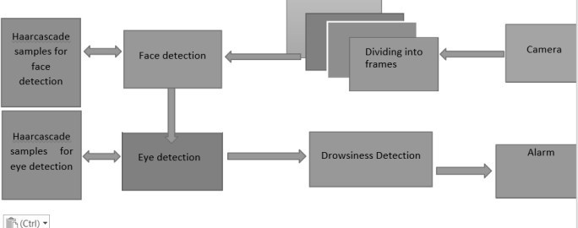

1. MATERIALS/METHODS USED

*A. Methodology used*

Eigen face approach for face recognition is very efficient and helpful because of its speed of operation simplicity in using and capability of learning. In computer vision face detection is done by use of eigen face which are basically set of eigen vectors. This approach is basically an appearance based approach which does face recognition by capturing the variation in a set of face images and this information is used for comparison and encoding of each individual faces in proper manner. What we mean by eigen faces is that they are Principal components of distributed faces which are represented in the form of covariance matrix of set of faces. In this method a face image is represented in the form of one dimensional matrix. We know we can represent a face in two dimensional form of pixels as N x N matrix in N2 dimension space. These N x N matrix is shifted to the form of row matrix. Many work on this were already done but it has ignored the fact of face stimulus which assumes that the given predefined measurements on face recognition are important and adequate. Which means that coding and encoding of available face images probably give information of face images which point outs the important significant features. But a chance is there that the obtained features may or may not be related to the known and required facial feature like nose, eyes, lips, hair etc. So, the extraction of required information from a face image is required. After extraction is done, we encode it with high efficiency and the result is compared with a database of faces encoded in the same fashion. For this purpose, we capture the variation with a collection of face images which is a very simple approach for the extraction of the information content. The next step is to find the Principal Component of the face distribution or from the obtained covariance matrix the Eigen vectors of the set of face images can be found out. Every row of image is considered as a vector stacked one after another in a single row which helps in displaying the Eigen vector as a sort of face. A liner combination of face images are taken to

represent each face images. We find that the sum total of all expected eigen faces is decided by total number of given input images in the prepared set. An approximation can be done for faces by the use of Eigen face for those having large eigen values which set the most variance in in case of available set of images. To increase the computational efficiency use of fewer Eigen face is done.

# Eigen values and eigen vectors:

In linear algebra, a linear equation in matrix form is represented by Ax= D.

The eigenvectors of a linear operator are non-zero vectors which, when operated by the operator. The result of this is a scaler multiple of them. For the eigen vector X the obtained scaler called eigen value (λ). A vector which is paralleled by linear transformation is called an Eigen vector. It is one of the property of matrix. When we calculate a matrix on it then the magnitude of the vector is changed. The direction of vector remains as it is. So we define as Ax = λx, where A is represented as a vector function. Then transforming the RHS part and writing it as (A − λI)x = 0, where I is called the identity matrix. The above form is a homogeneous equation and is fundamental part of linear algebra. Existence of non-trivial solution is decided by considering that if and only if Det(A − λI) = 0, where Det represents determinant. When it is evaluated we deal with the polynomial of degree n. This is known as the characteristic polynomial of A. If we represent the dimension of A by N x N then the solutions results in n roots of the characteristic polynomial. So it gives n Eigen values of A which satisfy the Axi = λixi , where i = 1,2,3,. n. If the obtained eigen values are all distinct

then we get n associated linearly independent eigen vectors with unique directions.

# Face Image Representation

In this approach we represent set of let’s say m images of each having size N x N. This is done by vectors of size N2. We represent each face Γ1, Γ2, Γ3… Γn. All those ₼obtained feature vectors are stored in the matrix with size N x N. One example is shown below which describes the entire process. For example:

# 3

**[3 7] = [7]**

# 6 5 6

**5**

Mean and mean centered Image and Covariance matrix We calculate the average face by

# Ѱ = ∑∞, Γ𝑛

𝑛**=1**

Then we find the difference of each face from their average face which is

# i = Γ i - Ѱ

We can construct a covariance as mentioned below. C = **AAT** , where A = [ 1, ɸ2,… ɸm] of size N2 X N2.

As we can see that the size of covariance matrix will be N2 X N2 which is huge actually and we need to find the Eigen vectors for the covariance matrix. But the large size makes it time consuming and tedious. To encounter this problem, we go for calculating ATA . Now let’s consider the eigenvectors Vi of ATA such that

# ATA Xi = λiXi.

The eigenvectors Vi of ATA are X1… Xn2. Now for simplifying we multiply the above equation with A both sides and we get

**AATA Xi = AλiXi AAT(A Xi) = λi(AXi)**

From above we clearly see that Eigen vectors responding to AAT is

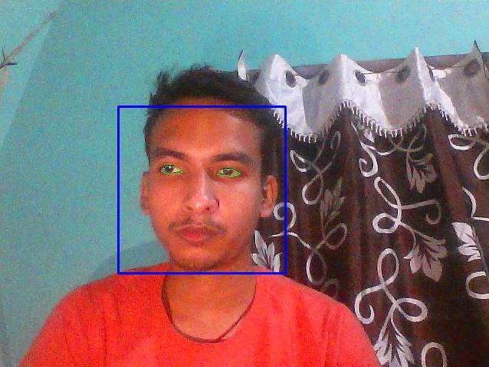

now firmly computed by reduction in dimension where AXi is the Eigen vector and λi is the Eigen value.

Eigen face space

Let’s say we have a covariance matrix AAT. So the eigen vectors corresponding to that matrix which is denoted by Ui where Ui represents facial images. Those eigen faces basically look like ghostly. Only those eigen vectors are accepted which corresponds to Eigen face in the face space and discarded faces are faces are having eigen values zero. This method helps to reduce the Eigen face to a great extent. Rank of Eigen faces are decided according to their usefulness to characterize the variation among the images. Here we project the face image into the face space by

Ωk = UT(Γk− Ψ); k=1,. , M,

where (ΓkΨ) is the mean centered image. Hence, we obtain the projection of each image as Ω1 for projection of image1 and Ω2 for projection of image2 and hence forth.

1. RESULT

The drowsiness detection system was completely implemented as the below flowchart:

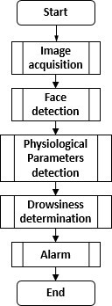

The table below shows the result generated on using the following system with the following test cases:

|  |  |  |  |
| --- | --- | --- | --- |
| Test | Number of  observation s | Number of  hits | Percenta ge  of hits |
| Assent of the head to the  right | 200 | 190 | 95.0 % |
| Assent of the head to the left | 200 | 191 | 95,5 % |
| Distraction to the right | 200 | 184 | 92.0 % |
| Distraction to the left | 200 | 193 | 96.5 % |
| Blink detection | 200 | 197 | 98.5 % |

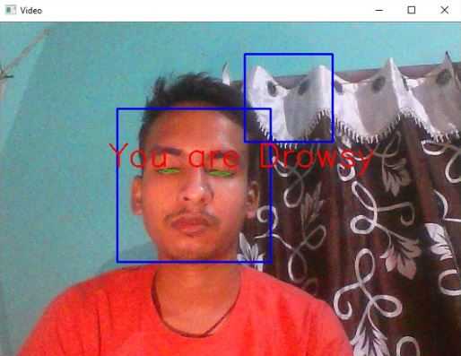

1. CONCLUSION AND FUTURE SCOPE

Our model is designed for detection of drowsy state of eye and give and alert signal or warning may be in the form of audio or any other means. But the response of driver after being warned may not be sufficient enough to stop causing the accident meaning that if the driver is slow in responding towards the warning signal then accident may occur. Hence to avoid this we can design and fit a motor driven system and synchronize it with the warning signal so that the vehicle will slow down after getting the warning signal automatically. Also we can avoid the use of RaspberryPi which is not so fast enough for video processing by choosing our own mobile phone as the hardware. This can be done by developing a proper mobile application which will perform the same work as RaspberryPi and response will be faster and effective.

In future we would also try to minimize the limitations that are in our project which include the following:

**Dependence on ambient light**: The model developed for this purpose strongly depends on the ambient light condition. As our algorithm considers the eye sight as a dark region when it is closed and brighter region when it is open so if the ambient condition affects such that there may be possibility of brighter and darker condition depending on light source then it causes error in the result. Also this model depends on certain minimum level of light condition otherwise it becomes very difficult to detect. To avoid this error we can use either LED light for better detection or we can use an infrared camera.

**Distance of camera from driver face**: For best result we have assumed and designed the code according to the fact that the distance between camera and face should be nearly 100 cm. Hence the designed set up output may vary from vehicle to vehicle as different vehicle have different types of seat lengths.

**Use of spectacles:** In case the user uses spectacle then it is difficult to detect the state of the eye. As it hugely depends on light hence reflection of spectacles may give the output for a closed eye as opened eye. Hence for this purpose the closeness of eye to the camera is required to avoid light.

**Multiple face problem**: If multiple face arise in the window then the camera may detect more number of faces undesired output may appear. Because of different condition of different faces. So we need to make sure that only the driver face come within the range of the camera. Also the speed of detection reduces because of operation on multiple faces.

Although there is no universally accepted definition for drowsiness, the various measures used to detect drowsiness include subjective, vehicle-based, physiological and behavioral measures; these were also discussed in detail and the advantages and disadvantages of

each measure were described. Although the accuracy rate of using physiological measures to detect drowsiness is high, these are highly intrusive. However, this intrusive nature can be resolved by using contactless electrode placement. Hence, it would be worth fusing physiological measures, such as ECG, with behavioral and vehicle-based measures in the development of an efficient drowsiness detection system. In addition, it is important to consider the driving environment to obtain optimal results.

A non-intrusive system to localize the eyes and monitor fatigue was developed. Information about the head and eyes position are obtained through various self-developed image processing algorithms. During the monitoring, the system is able to decide whether the eyes are opened or closed. When the eyes have been closed for two seconds, a warning signal is issued. In addition during monitoring, the system is able to automatically detect any eye localizing error that might have occurred. In case of this type of error, the system is able to recover and properly localize the eyes

1. REFERENCES

1]. W. Zhao, R. Chellappa, P.J. Phillips, and A. Rosenfeld, “Face Recognition: A Literature Survey,” ACM Computing Surveys, vol. 35, pp. 399-459, 2003.

[2] M. H. Yang, D. J. Kriegman, and N. Ahuja, “Detecting faces in images: A survey,”IEEE Trans. Pattern Anal. Mach. Intell., vol.24, no.1, , Jan. 2002, pp. 34–58.

[3]. Nan-Ning Zheng,Shuming Tang,Hong Cheng and Qing Li,Guanpi Lai and Fei-Yue Wang,”Toward Intelligent Driver-Assistance and Safety Warning Systems”,Intelligent Transportation System,IEEE 2004.

[4]. Christian Scharfenberger, Samarjit Chakraborty, John Zelek and David Clausi”, Anti-Trap Protection for an Intelligent Smart Car Door System”, 15th International IEEE Conference on Intelligent Transportation System, Anchorage, Alaska, USA, September 16-19, 2012.

[5]. K. C. Yowand, R. Cipolla, “Feature-based human face detection, “Image Vision Comput., vol.15, no.9, 1997, pp.713–735.

[6] An Analysis of Viola Jones algorithm for face detection by Yi-Quin Wang, University of Malaysia Phang, 2014, pp: 15-20.

Implementation of Voila Jones Algorithm by Ole Helvig Jensen, university of Denmark, 2008, pp: 20-